GGN - Geopark Annual Report 2018

1. GEOPARK IDENTITY
Geopark name, country, regional Network: Huanggang Dabieshan UNESCO Global Geopark, China (APGN)
Year of inscription / Year of the last revalidation:2018
Representative Photo (from the most important event this year)
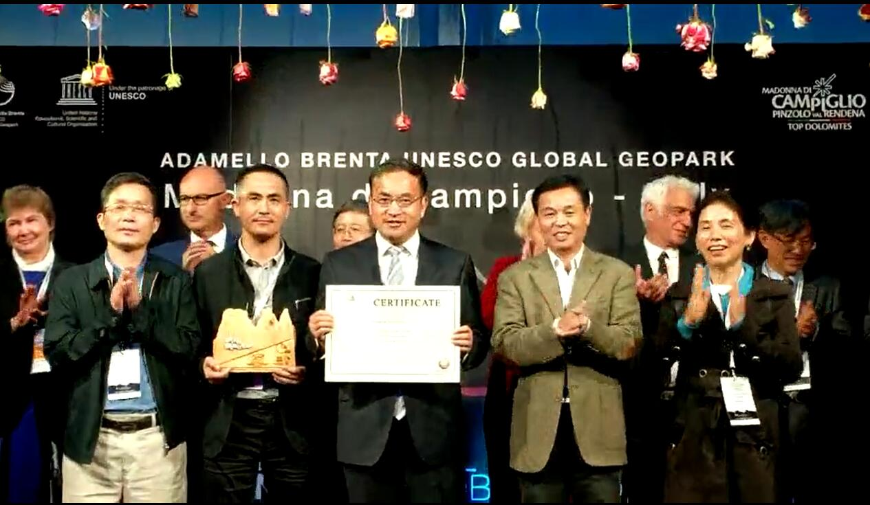
On 13rd Sept, 2018,Huanggang Dabieshan was approved to be an institutional member of GGN. in Italy
2. GEOPARK FIGURES
Number of Geopark staffs: 31staffs including 2 geoscientists
Number of Visitors:430 thousand
Number of Geopark events:70 held by management body and 30 by cooperative organization
Number school classes realize Geopark educational programmes:85
Number of Geopark press release:352

3. GEOPARK ACTIVITIES (bulleted)
Major achievements in 2018
£On 17th April, 2018 UNESCO’s Executive Board approved the designation of Huanggang Dabieshan UNESCO Global Geoparks, ranking as the 37th UNESCO Global Geoparks in China.
£From 11th to 14th, September 2018, the 8th International Conference on UNESCO Global Geopark was held in Italy. Delegates of Huanggang Dabieshan UNESCO Global Geopark attended with 2 poster presentations and was approved as an institutional member of Global Geoparks Network.
Contribution towards GGN - Networking and Participation
£Participate in the Chinese Volcanic Geoparks Forum, Leiqiong UNESCO Global Geopark, 2018/06 ---Abstract accepted & Oral presentation
£Participate the 2018 Annual Conference of Chinese UNESCO Global Geoparks, Yandangshan UNESCO Global Geopark, 2018/11--As a newly labeled UNESCO Global Geopark, a presentation concerned with the development history and management was given during the Conference.
£Participate in the 4th International Training Course on UNESCO Global Geoparks Management and Development with an emphasis on Earth Heritage Interpretation, 2018/10
£Visited by managers from Xiangxi, Longyan, Zhangye &Zigong UNESCO Global Geoparks to share experiences on management and development.
£There are 2 thematic interactive cooperation between Huanggang Dabieshan UNESCO Gloabal Geopark and Xiangxi Geopark based on Sistership Geopark Agreement signed in January 2018.
£ 6 Chinese and 3 English news concerned about activities in Huanggang Dabieshan UNESCO Gloabal Geopark was accepted in GGN website and GGN Newsletter respectively.
Management and Financial status
£ With a full budget from local government, daily business expenses is sufficient.
£ There is a central specialized fund in 2018, adding up to 12 million, among which 9.6 million is from the central specialized fund and the rest 2.4 million is from local government.
£ There is an one million annual special funds for the protection of geological relics from Department of Natural and Resources of Hubei Province, which can be used for geo heritages protection, interpretation panels updating and sciences popularization.
Geoconservation
£Having established a set of geoheritages protection inspection mechanism.
£ Having established a set of monitoring system for geoheritages.
£ Being in cooperation with China University of Geosciences (Wuhan) and other research institutes, which has laid a research platform for the protection and development of geological relics.
Sustainable tourism (Geotourism)
£ Having invested 450,000RMB for trails damaged by flood in summer.
£ Having designed another 4 geo-trails with different themes respectively.
New Education programmes on geoconservation, sustainable development and disaster risk reduction
£Having finished the main building of Geological Monitoring Station for Huanggang Dabieshan UNESCO Global Geopark, which is to be in use in the year 2019, playing a leading role in geoheritages protection, science popularization and scientific research.
Strategic Partnership
£Having been in partnership with China University of Geosciences(Wuhan) and Hubei Normal University, focusing on science popularization, information sharing and scientific research.
Promotional activities
£Under the auspice of UNESCO, a number of pictures and news has been published on the website of UNESCO, which is beneficial to the popularization of Huanggang Dabieshan UNESCO Global Geopark all over the world.
£Having set up an exhibition booth during the 49th Earth Day and 1st Alliance for Natural resources Popularizaiton held in Beijing, China, attracting more than 200 representatives in present.
£Being in cooperation with Kunlushan, Yangqin, Taishan etc, with pictures and brief introduction to Huanggang Dabieshan UNESCO Global Geopark in their museums.
£Participating in exhibitions held in Hongkong, Beijing and other national or international exhibitions, which help promotes Huanggang Dabieshan UNESCO Global Geopark.
£ Being in cooperation with Huanggang Daily, Hubei Daily and CCTV, more than 423 news are issued by Wechat and website.Some news are accepted in Hubei Daily, Huanggang Daily and other medias.
£Two articles concerning with the process from Huanggang Aspiring Geopark to UGGp were accepted.
£Attending in workshops held in Keketuohai UNESCO Global Geopark and Guangwushan Nuoshuihe UNESCO Global Geopark and make a presentation during the workshop period respectively.
4. Contacts:
Manager: Gao Zhifeng; hgdzgy@163.com
Scientific Responsible (Geologist): Li Feng; 531851997@qq.com

